IXth AGM DACAAI
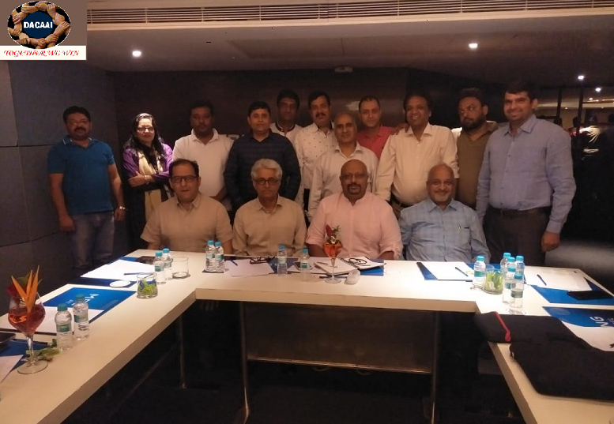
Minutes of Meeting Conducted at NOVOTEL Imagica, Khopoli, and Mumbai on 12th August, 2018

Following Attended:-
Mr .Arvind Nayak | Mr. RavijeetSehrawat
Mr. Suraj Agarwal | Mr. Satbir Malik
Mr. Anand Agarwal | Mr. Amit Singh
Mr. Dinesh Digga | Mrs. Pradnya
Mr. Ismail Khan | Mr. Deepak Moore
Mr. Roop Chand Baheti | Mr.Amit Bajaj
Mr. Sajjan Sharma | Mr. VivekDhawan
Col R P Shukla | Mr. Kailash Pandey

AGM commencedwith National Anthem

2 Minutes Silence and Prayer for Late Mrs Sandra (Paramount)Founder Member of DACAAI who passed away.

Welcome address by Mr. RavijeetSehrawat (VP DACAAI) in absence of President Mr Amit Gulati.
- He said thatresponsibility of DACAAI is not for few members, but each and every agentis responsible for the growth of DACAAI.
- We should respect of DACAAI in every aspect and together we will win.
- Over the years DACAAI has achieved many Miles stones with all stake holders of the Trade.
- In last 2 years many representations were made to the Government, Airlines and Terminals.

Update on last year activities ofDACAAI,given by Col Shukla
- 2 Meeting Menzies Bobba at Hyderabad to streamline the activates of the terminal
- Meeting for Delaying and creation of SOP and infrastructure for RFC.
- Meetings were conducted with Mr.SureshPrabhu, Honorable Minister Civil Aviation. Who assured that there will be a Domestic Air Cargo Policy which will be formed and issued by MOCA in due course of time?
- Meeting with CEO KekuGazadar, CEO AAICLAS for Domestic Air Cargo Policy.
- Liasonning for Allocation of DACAAI Office for DACAAI without Rent.
- Office is now furnished and ready for Functioning.

Accounts- Mr. Roop Chand Baheti gave detail of accounts and following points discussed and finalized:-
- Rs.8 lakh more of FD to be done by DACAAI.
- ITR of Last two year to be filed byMr.Baheti and return filed in Bombay. Any expenses for the same will be finalized by Mr.Baheti.
- Annual Fees can now be paid up to 90 Days after invoicing.
- Authorized Signatory changes to be done to operate bank account.
- Escalation Matrix for payment follows up – DACAAI Annual subscription
- Level 1 : First 60 days follow up byMrKailash
- Level 2 : 90 to 120 day follow up by Col R P Shukla
- Level 3 : 120 to 180 follow up by Treasurer
- Level 4 : Finally by Secretary, Vice President& President

Issues Discussed and Action Planned

GST – Representation to be made to GST Council
- Exemption of Perishable from GST
- Centralized Registration for GST for Service Sector
- Quarterly return of GST to be allowed

For above discussed points a draft to be made by Col R P Shukla by 15th September, 2018.

Terminals
- Single TSP invoice to be raised by Terminals for a period of fortnight.
- TSP to be Charged on AWB. No PDA accounts to be maintained.
- Terminal Committee to be formed under the Chairmanship of Mr.GauravGhuwalewala to make a Study of Infrastructure Shortfalls in the Terminals. Mr.Ghuwalewala to choose his own team to make the Study.
- Special focus to be given for Terminals in Kolkata, Hyderabad & Ahmedabad.

Airlines
- Policy for Appointment of Agents : Mr. VivekDhawan (Phoenix) will Propose the basic Agent Appointment to the Airlines. This is being done to Improve infrastructure at the first point of Contact for Customer and have creditable trade partners for the Airlines. he Policy to be finalized by 30thSeptember 2018.
- Change of Rates and Deals by the Airlines : The Airlines need to give 15 days notice before changing the Rates and Deals for the Trade. The Trade needs to adjust its Costs and inform clients of the Changes in time. Suggest dates for change is Start of the Month.
- Direct Selling to Clients. The Agents to be kept in loop and be part of the Corporate Contracts made by the Airlines.
- TSP to be charged on AWB no separate PDAs to be opened with Terminals by Agents.
- All Charges to be merged in Freight so a consolidated costs can be made transparent.

Revival of Grievance cell –
Grievance Cell has been activated under the Chairmanship of Mr.ArvindNayak.
Members: Mr.Arvind Nayak, Mr.Anand Aggarwal, Sajjan Sharma.

A policy with general guidelines will be prepared by Mr. Arvind Nayak by 15th of September 2018.

Training
DACAAI to empanel Training Companies for Different types of Training
- Basic Cargo Training
- IATA Training
- DG Training
- Excel Training
- Soft Skill Training
- Other Training that may be done by the empanelled companies.

Report/Schedule on above program Mr. Deepak (SD Cargo) for Trainers available at Mumbai and Col Shukla in Delhi by Sept 15th

Souvenir for 10 years DACAAI- To belaunched at Convention next year,
Contract of Preparation of souvenir will be given to Mr.Dinesh Kumar.

Associate membership by Airlines and Other – Preparation of broad guidelines byCol Shukla by 30thSeptember end.Responsibility for membership drive, station wise is as follows:-
Delhi – Mr.Amit Singh
Mumbai- Mr.Deepak Moore
Bangalore – Mr. Sajjan Sharma
Hyd – Mr. Rathod
Amd – Mr. SurajAggarwal
CCU – Mr. Rajkumar Gosh

DACAAI registered office to be changed from Mumbai to Delhi – Responsibility Mr. Roop Chand

Parking fee issue of private cars with GMR of DACAAI members – Parking to be made free for DACAAI members. Col Shukla to take it up with GMR.

Formation of New Committee

Managing Committee
Mr. Amit Bajaj – President, Mituj Marketing Pvt. Ltd. #9818557771amitbajaj@mituj.com
Mr. RavijeetSherawat– Vice President—Surya Cargo Pvt. Ltd. #9811123200-- ravijeet@suryacargo.com
Mr. Suraj Agarwal- Secretary, Monopoly Cargo Services P. Ltd. #9373105188 surajagrawal@monopolycargo.com
Mr. Ismail khan – Joint Secretary, Index Logistics #8108108811,ismailmd@indexlogistics.in
Mr. Roop Chand Baheti - Treasurer, Bhagwati Cargo #9313651468, roopchandbaheti@gmail.com

Executive Committee
Mr. Arvind Nayak, Nayak Aviation Pvt. Ltd.
Mr. Anand Agarwal–EFS, Mumbai
Mr. SajjanSharma, Carex Cargo Bangalore
Mr. Deepak More, SD Cargo
Mr. Amit Singh, Phoenix Cargo

Meeting was closed with Vote of Thanks by Col Shukla

Best Regards

DACAAI

