Minutes of Meeting 11th AGM DACAAI
Date: - 26th to 28th Nov 2021
Venue: - Jim Corbett, Ramnagar, Uttarakhand

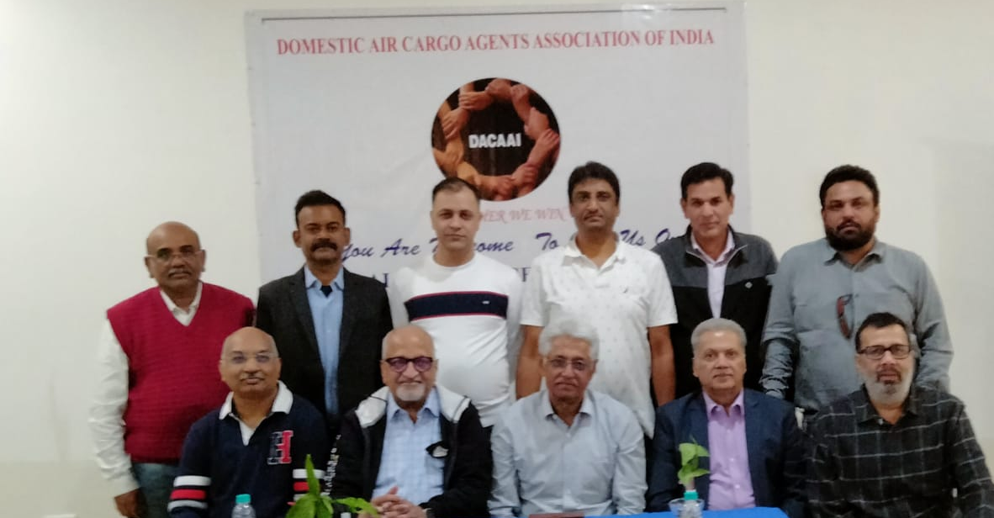

Attendees:-
- Mr. Arvind Nayak (Nayak Aviation)
- Mr. Amit Bajaj (Mituj Marketing)
- Mr. Ananda Agarwala ( EFS India)
- Mr. Suraj Agarwal (Monopoly Carrier)
- Mr. Ravijeet Sehrawat (Surya Cargo)
- Mr. Roop Chand Baheti (Bhagwati Air Xpress)
- Mr. Dinesh Digga(Bhagwati Air Xpress)
- Mr. Vikas Porwal ( Patel Integrated)
- Mr. K Suresh ( Patel Integrated)
- Mr. Sajjan Sharma(Carex Bengaluru)
- Mr. Vijay Gupta (KMX India)
- Mr. S S Rawat (Whiteline Airways)
- Mr. Dinesh Kumar (DACAAI)
- Mr. Kailash (DACAAI)

AGM Points Discussed-
- Welcome by Dinesh Kumar
- 2 minutes silence
- Meeting called to order: Vice President Sh. Ravijeet Sehrawat
- Passing of 10th AGM minutes- amicably passed

- President's address - Sh. Amit Bajaj – Thanks to everyone and special thanks to Mr. Suraj Agarwal and support of Sh.Nayak Sir and immense support by Bhaeti Ji in financial support. During past four years we started to connect with members of DACAAI through the ‘DACAAI WhatsappGroup’by virtually celebrating their B’day. Secondly, DACAAI shared other information on whatsapp group and through “e-Interconnect” which we are sharing with all industrycontacts regularly i.e airlines, CUTs & Govt sector.

We approached and interacted withMoCA frequently with the help & support of Mr. Suraj Agarwal, Sh. Arvind Nayak & Mr. Dinesh Kumar.

DACAAI was invited by FICCI, PHD, Ministry of CA& Govt Departments in variousforum and industry platforms.DACAAI has been recognised as a major stakeholder in industry we need to continue this.

We shared DACAAI thoughts with Govt’s upcoming Schemes like as Krishi Udan. Recognition of DACAAI was being pursued by us for a long time. Finally, DACAAI has been recognized as a legitimate Stakeholder in AERA. All Govt meetings were attended by DACAAI office bearers, Mr. Dinesh Kumar and Managing Committee regularly.

We met theand gave presentations to hon’ble MoSCA Sh.Hardeep S Puri&HMCA ShJyotiradityaScindia and they considered our request & reports on growth of Domestic cargo & Infrastructure and that is a big achievement for DACAAI.

We had been called by Various CUT operators seeking suggestions, and DACAAI voice is beingheard and action is taken by them.

At last it’s been an honor for me to represent DACAAI. Thank you all for your support.

- Secretary's Report - Suraj Agrawal welcomed all. He saidour members served the nation in tough time during Covid pandemic, our team members including all the airlines everyone has gone ahead to work 24 hours during this period also to serve the nation. I would like to convey special thanks to Sh. Dinesh Kumar for the past 2 years achievements. We had VC meeting with Sh. Nitin Gadkari ji and we have taken up some important issue with him and he took up our issues with other ministries like Finance & Civil Aviation. Lots of meetings were attended by Dinesh Ji representing DACAAI.We had metMrScindia
- the HMCA and explained our issues.However, we miss our follow up on issues we take up with ministry. We have covered 12 years and now we are coming with ‘Year Book’publishing 12 years’ activity.We request DACAAI members to contribute their profile and advertisement at nominal cost of Rs. 30,000 only along with their thoughts/articles also. Lastly,
- We have to take infrastructure issues with Ministry/CUT operators aggressively.
- Dinesh ji to visit local regional meetings to energies our association members
- Regarding the delay of payments of MSME clause and GST clause how to implement it at Govt end. We have already sent a letter to ministry and a follow up is required.

- Presentation of Accounts 19-20 & Budget 2021-22:- Sh. Roop Chand Baheti presented Audited accounts. He informed that an amount of Rs. 5.20 lakh is yet to be received from membership fees. FD and Current Accounts position, PL sheets will be shared with the Managing Committee.
- New applications received for DACAAI membership will be considered after approval byfrom MC. If applicant is an agency then it is to be counted as National Member otherwise to be counted in Associate Member category.
- Regarding Membership fee for Covid pandemic year invoicing for the year 2021-22 is to be raised @ minimum 10,000 and up to 50% of Membership Charges.

- DACAAI Activity Report - by Dinesh Kumar – As President has covered the activity in detail in his presentation he said it was pleasure to work with DACAAI managing committee. He stated that he worked with the three principals to make DACAAI strong are :
1) Show your visibility;
2) Show you are in the business and know your business, convey it ; and
3) Strong focus andconstant interaction with Govt and industry forums.
He was available for any advice and assistance required of him.

Sh. Nayak acknowledged the contribution by Shri Dinesh Kumar andsaid being a part of our industry for a long time we gained from your experience and with you being on board with us,DACAAI definitely achieved a lot. We are very proud of you.

- Progress of 'DACAAI year Book' : Shri Suraj Agrawal informed that we have received a total funding of Rs. 6 lakh has been received by DACAI. We have to fix a deadline for our members to contribute @ 30k advertisement and their company profile and should publish it asap as we have funds from our industry stakeholders. It was decided that Managing Committee will pursue DACAAI Members to contribute in Year Book.

- Airport wise/CUT wise discussions- Opening discussions on this important topic Sh. Arvind Nayak stated thatwhile our thought was we will get benefited from CUTs & we welcomed it.But our experience past five years has shown that as a Domestic Agent we are disappointed.

- We have ended up in paying additional cost to CUTS for very substandard service.Lets us discussed CUTs problem, We fail to be convinced with CUT concept. Actually, CUTs did not help in our Business but CUTs are becoming expensive nowadays.They are running bonded truck and may take all other services being performed by us.

- Somewhere down the line we also stared supporting ACFI which was formed by Terminal operators and promoted by GMR. In effect ACFI replaced ACAAI & DACAAI and became the sole representative of our industry to the govt. Every rule regulation from then is based on the recommendation of ACFI.What will stop them to opening their own shops, Domestic booking counters etc.This is the one of point we will have to do to reverse it. Otherwise it’s going to eat into our business. Major focus of DACAAI should be to convince the Govt that the CUT role has to be limited to infrastructure supply, Infrastructure development and taking the cost from that infrastructure like you build road and collect toll.

- Sh. Amit Bajaj said these terminals are major problem with us.DACAAI is generally being projected as anti-terminal organization. We are not Anti-CUTs.As DACAAI we need to accept that for the growth of air cargo a CUTs model has to exist. CUTs are a concept for smaller airlines. We need it as anorganization for the growth of air cargo.But in metro cities for big airlines CUT need to provide self handling options, Once the airlines take the self handling that would be shared easily with the agent the and Costing will be taken care. There has to be valid competition between the terminals and end the monopoly of CUTs.

- Sh. Arvind Nayak said DACAAI members are on city side where AERA has no role, AERA can regulate airlines not us. AERA has no role to play over city side agency. We should send a letter to secretary /Minister on this clarifying our position. Sh. Amit Bajaj said if you want to rationalize the charges it has to be worked with AERA as per Govt. parameters.

- Mr. Vikas Porwal said CUTs are not providing Manpower for handling cargo and there is shortage of X-ray machines in major airport CUTs; there are Delays in cargo acceptance and delivery. The CUTs concept has been hijacked by terminals operators.

- Sh.Arvind Nayak.We should take expert opinion on these issues under guidance of Mr. Dinesh Kumar. We will have to enter into discussion with CUTs; make a white paper; CUTs have no role in DACAAI and there are no domestic CUTs abroad. Finally we need to approach Ministry/AERA for the same with the advice of experts.

- The issues to be taken up with Ministry/AERA are as under :
- Outbound/Inbound charges to be reduced and rationalized, Airlines should also address their charges. AAI-Kolkata CUT model for small cities should be recommended for implementing.
- Lack of CUT operator handling Manpower at Terminals
- Agents role vis a vis carrier’s role

- Delay in Cargo acceptance and delivery – outbound & Inbound
- RavijeetSehrawat :DACAAI has to request and define SLA with airlines for cargo acceptance and delivery; we need to signed SLA with airlines
- Amit Bajaj :DACAAI members have to come out with SLA requirements
Election for New Managing Committee
The following members were elected to the Managing Committee unanimously:
New Managing committee:-
- Sh. Arvind Nayak (Nayak Aviation) –President
- Mr. RavijeetSehrawat (Surya Cargo)- Vice-president
- Mr. Suraj Agarwal- (Monopoly Carrier) Secretary
- MrRoop Chand Baheti (Bhagwati Air Xpress)– Treasurer
- Mr. Deepak More (S D Cargo)– Joint Secretary

Executive Committee-
- Mr. Amit Bajaj
- Mr. Gaurav Ghuwalewala
- Mr. Ismail Khan
- Mr. Sajjan Sharma
- Mr. Vikas Porwal
- Mr. Vijay Gupta

Mentor – Ananda Aggrawala
Presiding Officer – Mr. Dinesh Kumar
Induction of New Managing Committee
The New managing committee was inducted and took over with good wishes from all members. President Shri Arvind Nayak thanked the AGM and the DACAAI all members for reposing confidence in him to lead DACAAI once again which he would do with the support of the MC and DACAAI members.
Other Points with permission of Chair
Membership Drive:Suraj Agrawal stated that other Stakeholders like Airlines, CTO’s and others should be brought in DACAAI as Associate/Corporate Members category.We need to approach to airlines with nominal charges for membership on yearly basis, A charge of 50 K yearly was decided by New MC. Shri Suraj Agarwal said we have to take membership of ASSOCHAM also to broad base DACAAI.

Members' Speak –
There was need to regenerate the Grievance cell. The cell had worked very well and solved certain issues among the members on outstanding and over dues. Due Covid it was not active. It was decided to Head the GC by AnandaAggarwala. Grievance cell is only to help members to recover money from defaulter.
Mr. S. S. Rawat asked, for bad debts/payment default what kind of action can be taken through DACAAI. Sh.Arvind Nayak said we need to circulate information of bad debts/willful defaulter to the internal members. We must highlight those members who did not pay the members outstanding for more than 6 months. DACAAI, however, has no role to reconcile the accounts.
Sh. Amit Bajaj saidthat we should take legal advice before putting defaulters names in publically or in public domain. DACAAI may create a page on website for defaulters.If this did not work then DACAAI should circulate only information of willful defaulter internally. DACAAI may also approach to Airlines not to give stock/agency to such defaulters. DACAAI will help Airlines also in recovering their dues, if any.
If an agent/Outsider will default with the members of DACAAI and working with another member in that case new member must fix up a joint meeting for both parties to help in recovery.If any outsider make more than one default in that case he is a willful defaulter and DACAAI will share the information to members.
Action Points-
1) Membership Certificate will issued with the Membership Number
2) DACAAI Email to migrate to Gmail – Shri Amit Bajaj
3) New mobile numbers for DACAAI
4) e-Membership certificate to be given via PDF to members
5) Audit of DACAAI Accounts
6) SOP/SLA for DACAAI members to be circulated
Summing up- Vote of Thanks by Dinesh Kumar
Shri Dinesh Kumar thanked the members for their valuable contribution and support in conducting the 11th AGM and wished that the new MC would take the DACAAI further with cooperation among all.
Date for next AGM –Was fixed in Second week of Jan 2022 at Delhi as per by laws
Close
DACAAI
Secretariat

